3 CrownJewel

When we see the system log file we get to know that the services that are stated are all in the event id 7036

There we get to know about the
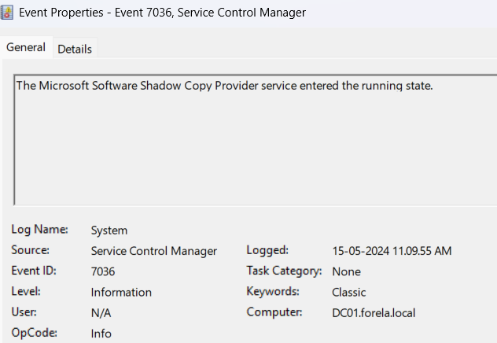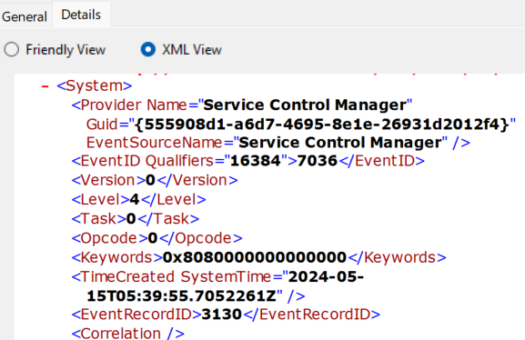

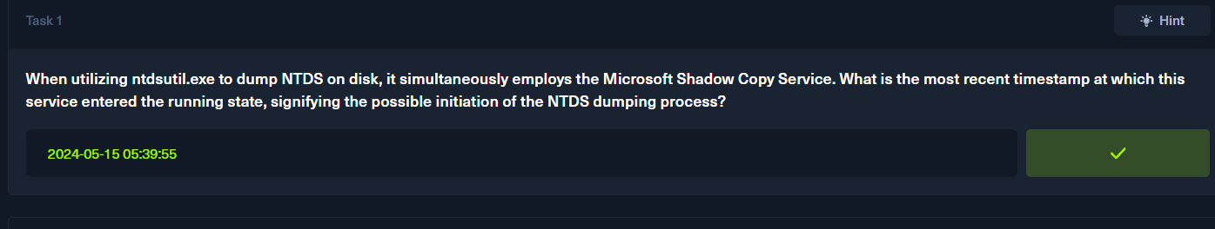

When we analyse the application event of the event log data
We get toknow that for detached database the event id is 327
For attached database is 326
And for creating a new database is 325
So by analyzing this we check the all the event id 327 and then get to know the dumpes database

C:\Windows\Temp\dump_tmp\Active Directory\ntds.dit
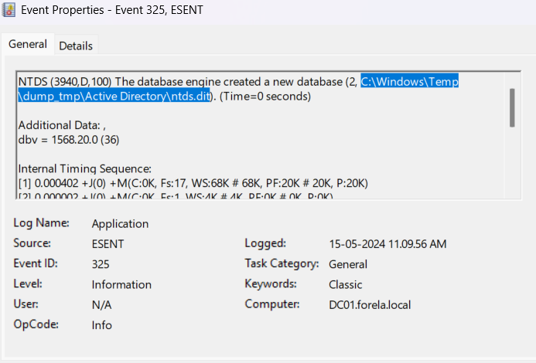

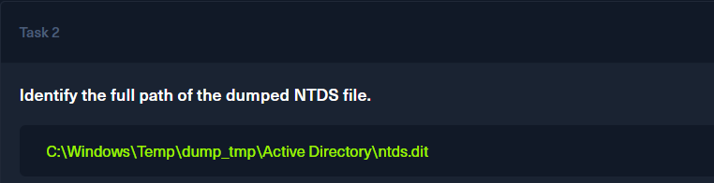
Lets see when it is created
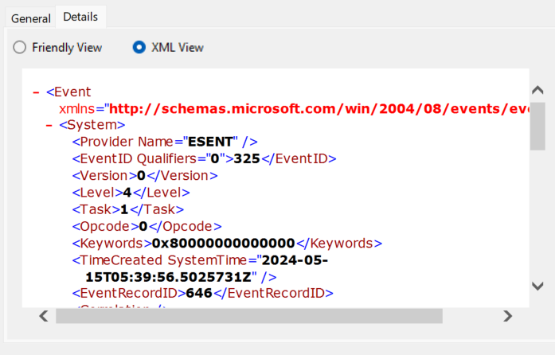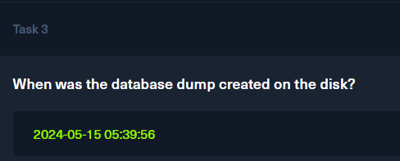

Then we look for hen the database is detached
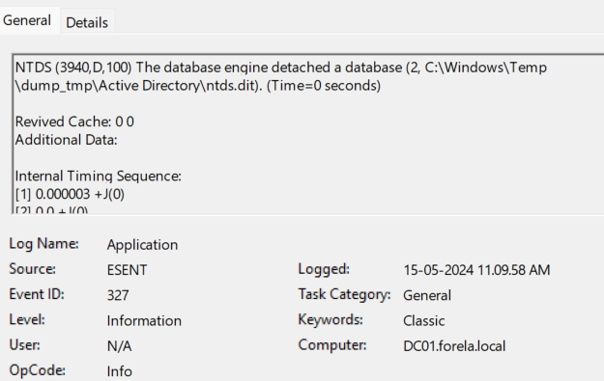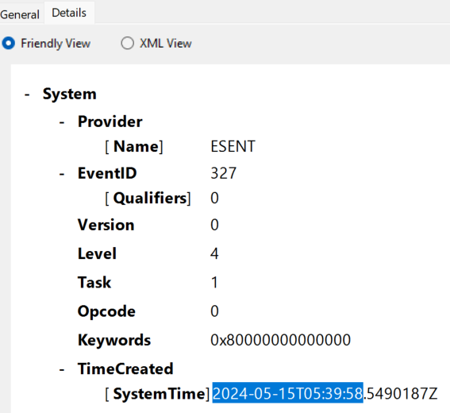

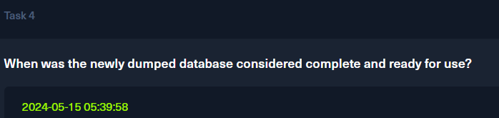

We can clearly see in the above that the event name is ESENT
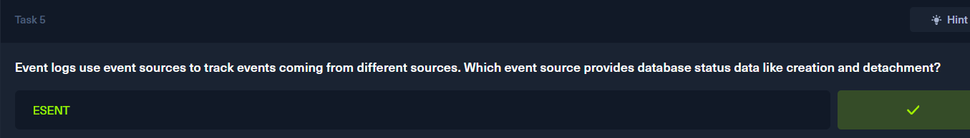

We just found the two names from the security group management
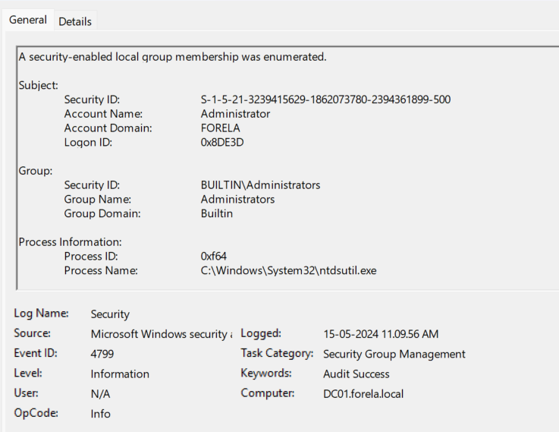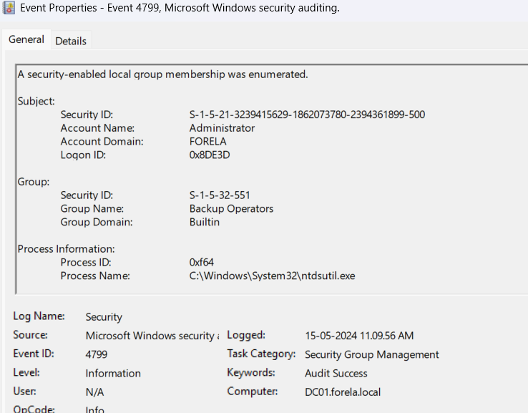

We can see the two group names in it
Administrators and Backup Operators
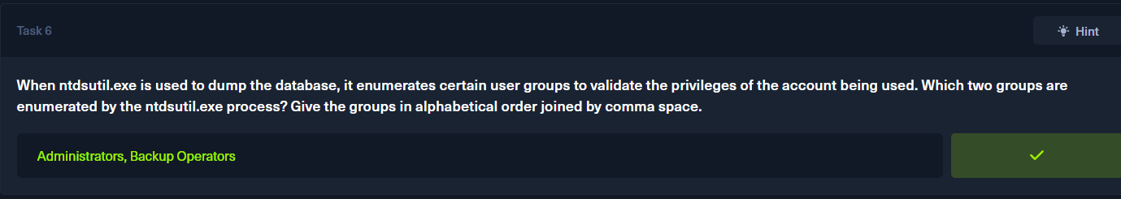

And the logon id is
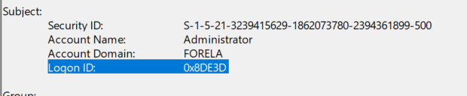
0x8DE3D

We filter the logon ig in the security logs and checked that in the user acoount management the logon id credentials were read
